

**AMITY SCHOOL OF ENGINEERING & TECHNOLOGY**

**Project Synopsis**

**B. Tech (CSE)**

**Group No.:** 36

**Project Title:** Multispectral Land Cover Analysis and Change Detection for Assessing Environmental Dynamics

**Area:** Machine Learning, Image Processing, Data Analysis

**Academic Session: 2023-24**

**Project Guide:** Dr. Abhishek Singhal

**Details of Project Team:**

|  |  |  |  |
| --- | --- | --- | --- |
| Programme:- | | Year/Semester:- | |
| S. No. | Enrollment No. | Name | Signature |
| 1. | A2305220034 | Shruti Verma |  |
| 2. | A2305220103 | Utkarsh Chauhan |  |
| 3. | A2305220148 | Nayan Ranjan Das |  |

**Project summary (at least 250 words):**

The research project focuses on the development of a hybrid model for change detection analysis in time series land cover data, aiming to identify alterations in physical features such as deforestation and soil degradation. The primary objective will be to train an advanced model capable of accurately detecting changes over time. To achieve this, change detection algorithms such as Siamese Networks, Recurrent-CNN (Recurrent Temporal Convolutional Neural Networks), and RNN/LSTM (Recurrent Neural Network/Long Short-Term Memory) will be used.

Siamese Networks provide a foundation for feature matching, Recurrent-CNN contributes temporal convolutional capabilities, and RNN/LSTM facilitates the modeling of sequential dependencies in the data. The integration of these techniques ensures a holistic approach to change detection, allowing for the identification and characterization of diverse land cover transitions. Additionally, the research introduces improvements in the preprocessing algorithms to further enhance the model's performance in detecting significant changes in physical features.

The outcomes of this research will be presented through a comprehensive dashboard, designed to visually represent the detected land cover changes. The dashboard serves as a user-friendly interface, offering an intuitive visualization of the results generated by the hybrid model and the improved preprocessing algorithms. Through this graphical representation, users can gain insights into the identified changes in physical features such as deforestation and soil degradation over the analyzed time series. The incorporation of a dashboard enhances the accessibility and interpretability of the research findings, making them more readily available to a broader audience, including policymakers, researchers, and environmental practitioners. Through this innovative combination of methodologies, the project aims to contribute to the advancement of change detection analysis in time series land cover data, with potential applications in environmental monitoring and resource management.

**Methodology to be adopted:-**

1. Literature Review:
   1. Review literature on Siamese Networks, Recurrent-CNN, and RNN/LSTM for change detection and preprocessing techniques.
   2. Identify key methodologies and innovations to inform hybrid model development.
2. Preprocessing Enhancement:
   1. Analyze and adapt preprocessing for Siamese Networks, Recurrent-CNN, and RNN/LSTM to optimize for project requirements.
   2. Implement modifications for enhanced accuracy in detecting land cover changes.
3. Model Development:
   1. Integrate Siamese Networks, Recurrent-CNN, and RNN/LSTM into a cohesive hybrid model.
   2. Train and fine-tune the hybrid model with a labeled dataset for change detection.
   3. Implement validation for robustness and generalizability.
4. Model Deployment:
   1. Deploy the hybrid model in the target environment.
   2. Validate performance in a live setting, addressing deployment challenges.
5. Dashboard Development:
   1. Utilize final results to design a web-based dashboard.
   2. Incorporate interactive visualizations and user-friendly features for accessibility and interpretation.
   3. Ensure seamless integration with the hybrid model for real-time updates.

**Resource requirement (Hardware & software etc):-**

Discrete GPU for training deep learning models, Python for framework development, Python modules - tensorflow, pytorch, mlx, numpy for various tasks.

**Justification of the project:-**

The justification for undertaking the project lies in the critical need to address environmental challenges such as deforestation and soil degradation. These issues have far-reaching consequences for ecosystems, biodiversity, and sustainable resource management. Traditional methods of monitoring land cover changes are often labor-intensive and lack the precision required for timely intervention.

The hybrid model proposed in this research leverages advanced machine learning techniques, including Siamese Networks, Recurrent-CNN, and RNN/LSTM, to enhance the accuracy and efficiency of change detection analysis in time series land cover data. By combining these methodologies, the project aims to create a comprehensive and robust approach that can identify and characterize diverse land cover transitions. This is crucial for understanding the dynamics of environmental changes, particularly in regions susceptible to deforestation and soil degradation.

The integration of improved preprocessing algorithms further underscores the project's commitment to enhancing model performance. These enhancements not only contribute to the accuracy of detecting significant changes but also showcase a dedication to refining the entire analytical pipeline. The research's ultimate goal is to provide a reliable tool for environmental monitoring and resource management, facilitating informed decision-making by policymakers, researchers, and environmental practitioners.

The creation of a user-friendly dashboard adds an additional layer of justification, as it ensures the research outcomes are accessible and interpretable to a broader audience. The graphical representation of detected land cover changes allows for intuitive visualization, making the information more readily available for stakeholders who may not have a technical background in machine learning. This democratization of information aligns with the project's overarching aim of contributing to the advancement of change detection analysis in time series land cover data, with tangible applications in addressing pressing environmental issues.

**PERT Chart/Schedule of project completion:-**

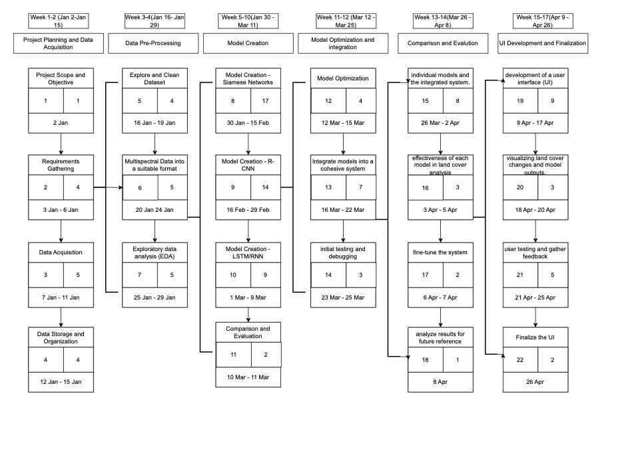

**References: Research papers / books / websites etc.:-**

Cartwright, Hugh, and MARTON. *Artificial neural networks*. Ed. Hugh M. Cartwright. Vol. 1260. Humana Press, 2015.

**Signature(s) of project team Name and Signature of project guide**

Shruti Verma

Nayan Ranjan Das Dr. Abhishek Singhal

Utkarsh Chauhan

**Date: 4 January 2024**